1. Make record of ID, this is KEY code to activate Windows OS.

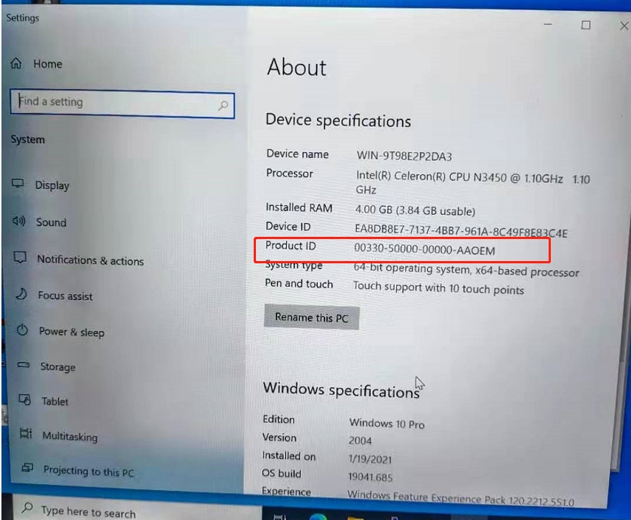

1. Prepare a U disk，format into **FAT32**，Volume lable as **WINPE**，

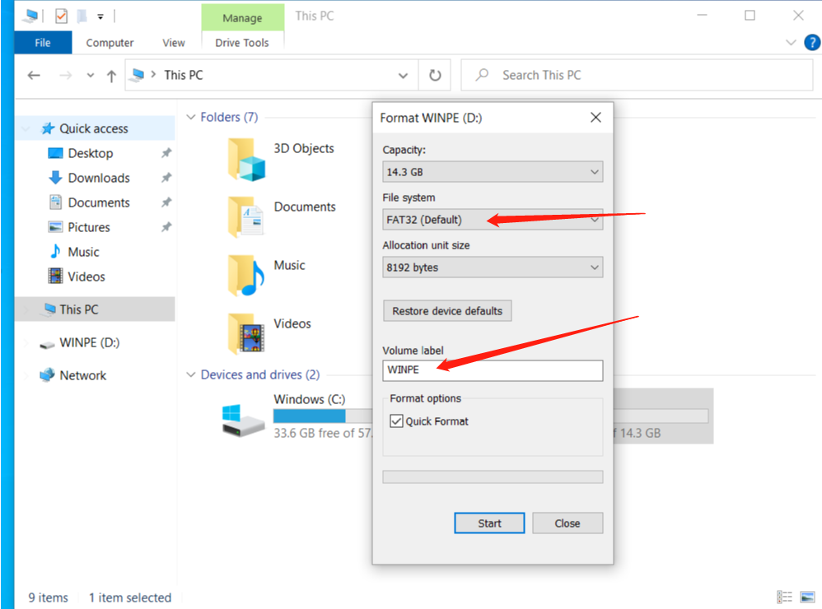

1. Copy BIOS file into U disk root directory.

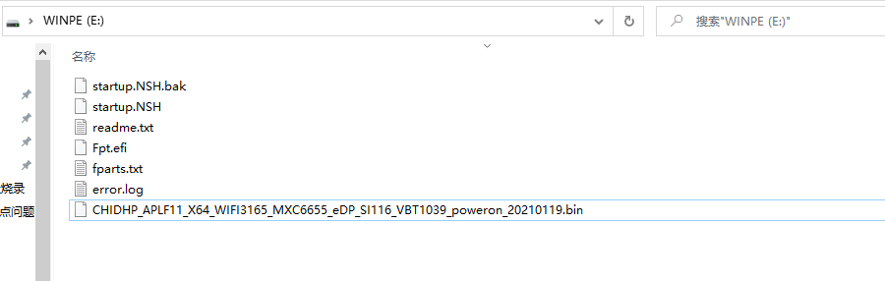

1. Connect device to keyboard and U disk.
2. Powering on first see Intel Logo then fast click on F7 button, to get into SETUP interface.

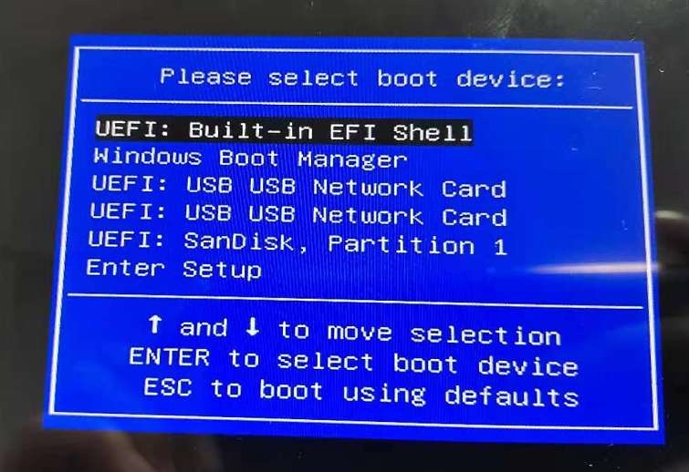

1. Choose UEFI:Built-in EFI Shell，press Enter button.
2. After pressing Enter button, it will run automatically for few seconds then get into below pic interface.

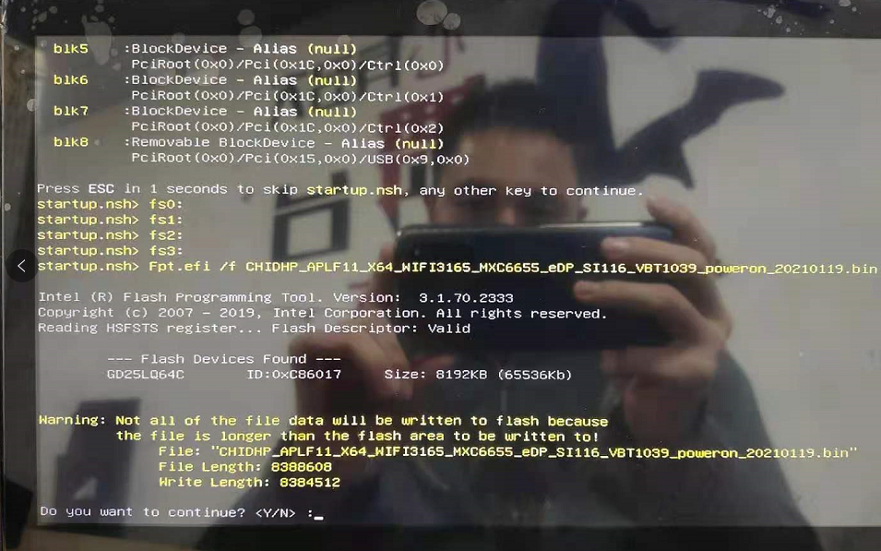

1. Now need to press Y on keyboard to choose YES, then press enter.

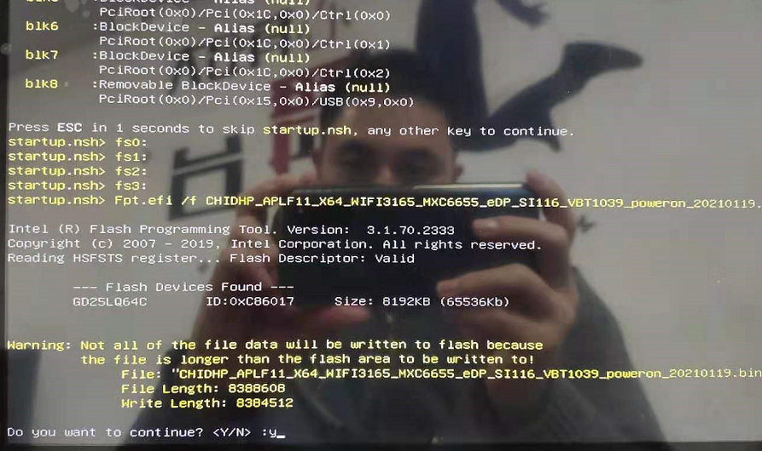

1. Then just wait for about 5 minutes for the process finish. Automatically, no need to do anything but wait.

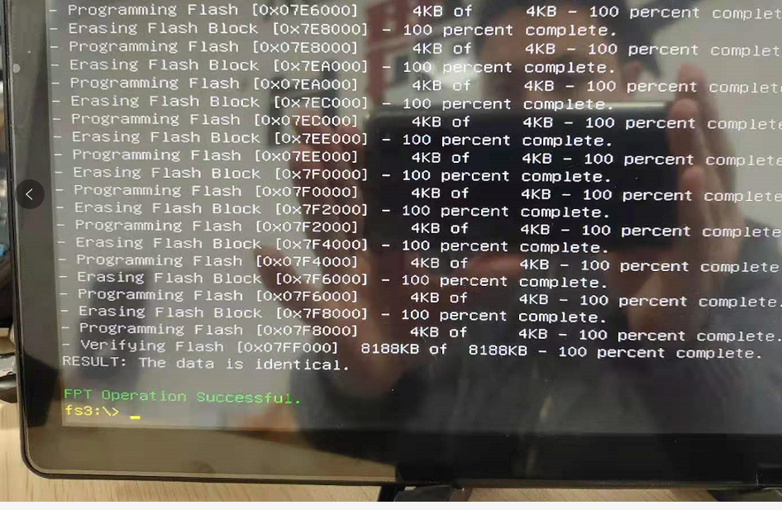

1. Now BIOS is finished updating when we see the words FPT Operation Successful, then press “Ctrl + Alt + Delete” simultaneously to restart the device.

**To activate the device.**

1, Open the setting interface and select Update and security (Note: connection to the network is required)

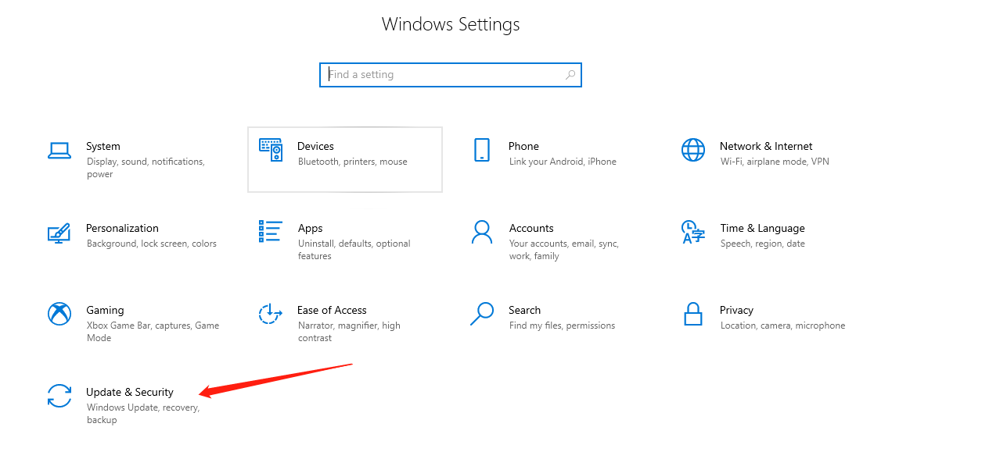

2, Select Activation to change the product key.

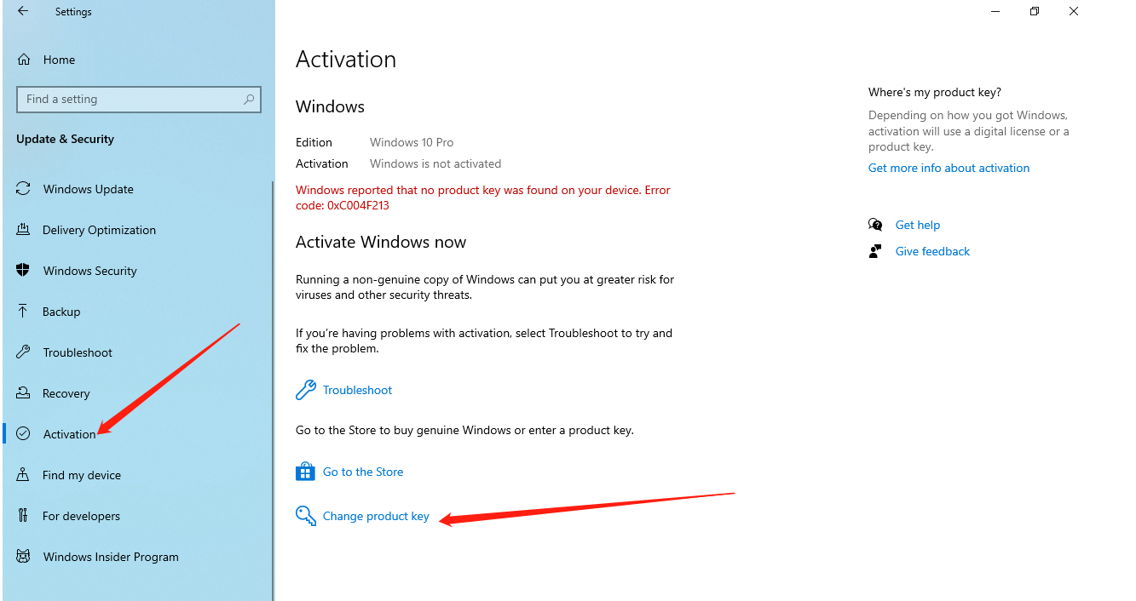

3, Click to change the product key,enterthe5*5key,and then click Next.

(Note:**Network connection is required**)

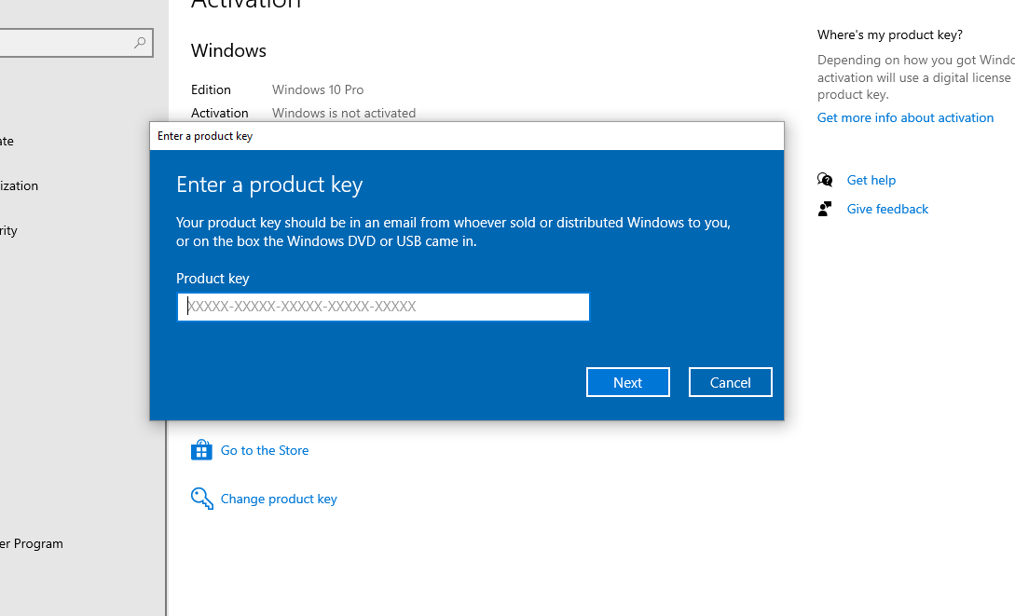

4, To check whether the activation is successful, ind the"System"option in the

Setting interface and click enter.Then"About"interface.

System information, as shown below.

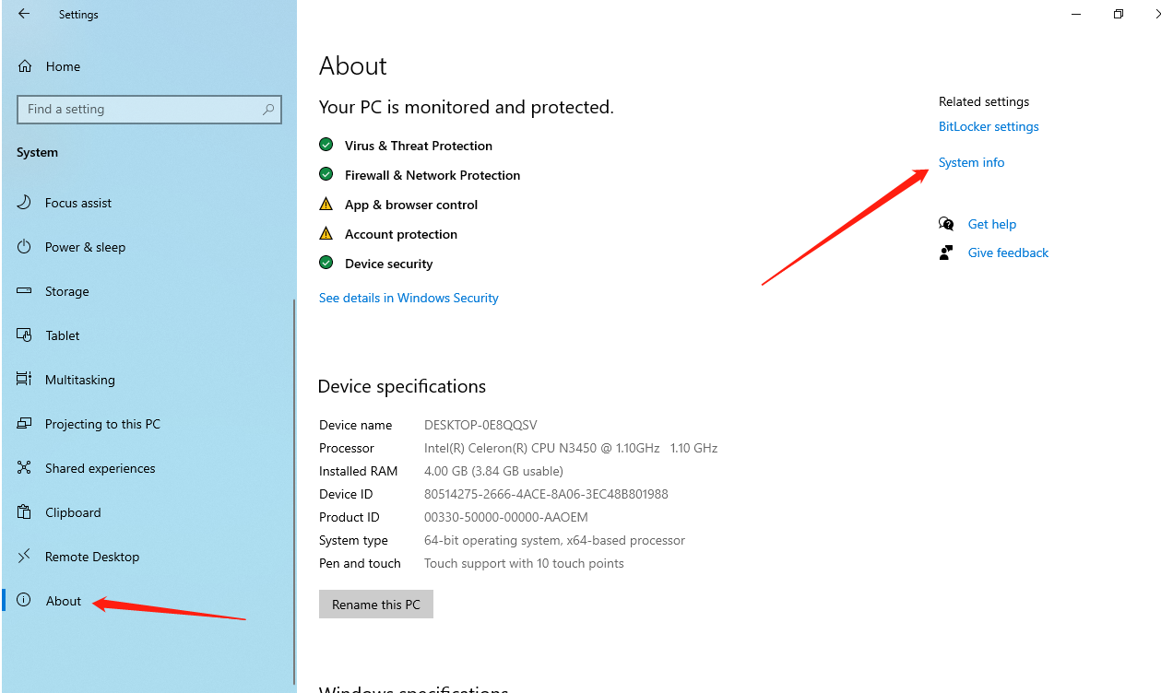

5, Click the system information to view the following, which shows that the activation if successful.

